**Student Name : Lalit Kumar** **Roll No. : 21f3001013**

**Proposal: BDM Project**

1. **Executive Summary and Title**
   1. Title: Analysis of Business of Officers Mess Air Force Station Pune
   2. Executive Summary: Officers Mess of Air Force Station Pune is a club for Air Force Officers posted at Air Force Station Pune. It caters facilities for approximate 250 permanent members and 500 officers transiting through the city. It offers the facilities of transit rooms for accommodation, restaurants for dining, bar, gymnasium, sports facilities, library, party rooms and other facilities. This Officers Mess works on a business model akin to clubs and resorts with income generated from monthly contributions by the members and charges from various facilities like rooms, restaurants, bar, sports facilities etc. Expenditure involves mainly towards payment of wages of employees and maintenance of all facilities in the mess. Generally, the Officers Mess Air Force Station Pune maintains a healthy annual growth of 4 to 8 % per year, however the business model of this mess got affected by the Covid -19 pandemic. This project is undertaken to analyse the business model of this club and study effects of Covid-19 on the growth of the club. The project would also study the steps taken by the club to mitigate the effects of the pandemic. The project would involve study and analysis of data comprising of monthly trial balances and yearly audit reports to derive the insights. The project would involve use of tools like Microsoft Excel along with its charts facilities to compare and analyse various financial variables available in these financial statements.
2. **Data Collection**.
   1. Following is the Organisation chart of the Officers’ Mess Air Force Station Pune:-

Chairman

President Mess Committee

Mess Secretary

Mess Manager

* 1. Day to day management of the mess is carried out by the Mess Secretary. Mess Secretary appointment is tenanted by Squadron Leader Prabhjot Singh. He was requested to provide financial data of the mess for the research work towards ‘Business Data Management’ project of IIT Madras. A meeting was held with the officer on 01 December 2022. In second meeting on 15 December, he agreed to provide data from 01 January 2019 to 31 December 2022 after obtaining necessary permissions from higher echelon, Data was received through email on 10 January 2023. A letter by the Mess Secretary agreeing to share the data is annexed as Appendix ‘A’. Few photographs of the meeting are annexed as Appendix ‘B’. A short video of the interaction is also included in the zip file.
  2. The Officers’ Mess Air Force Station Pune provides club services to the officers and their families posted at Air Force Station, Pune. It also caters for the visiting officers and families. In compact, the mess can be compared with a club with restaurants, bar, party rooms and guest rooms.
  3. As the mess caters for more than 250 officers and families in terms of recreational facilities, the mess suffered during the Covid-19 period, as all the recreational facilities were closed down. However the mess had to pay for wages and maintenance activities.
  4. Idea behind the research is to study the financial model of the mess and effect of Covid-19, if any.
  5. The data was provided through email and data span is from 01 January 2019 to 31 December 2022.

1. **Metadata.** The data received was in 36 excel sheets with monthly revenue and expenditure statements from 01 January 2019 to 31 December 2022. Interest on the bank deposit is paid on yearly basis and the amount received from bank was given in yearly statement. The Officers’ Mess Air Force Station Pune maintains following main ledgers :-
   1. Food. The mess provides food facilities to around 100 living-in officers (These are the officers who dine in the mess. It is similar to the hostel dining set up). Additionally, this service is also provided to the officers who come on temporary duty to the base. The dining members are charged fixed amount every month for regular services and are charged extra for extra messing items. Visiting officers are charged fixed amount per day.
   2. Bar. Bar facility is provided to all the officers and their families of the base. Additionally, this facility is also utilised by retired officers and officers coming on temporary duty to the base.
   3. Guest Rooms. There are 50 guest rooms in the mess and they are occupied by the officers who have come on posting but yet not allotted accommodation. Additionally, these rooms are given to the officers coming on temporary duty to the base. The charges for these rooms vary from Rupees 600 to Rupees 900 per day depending upon the type of rooms.
   4. Party Halls. There are two party halls in the mess and they are booked by the officers to celebrate anniversaries and birthdays. These party halls booking charges are Rupees 1000 and Rupees 1500.
   5. Mess Subscription Charges. All the posted officers of Air Force Station are mandatorily the members of the mess and they have to pay minimum subscription charges every month. An amount of Rupees 800 is charged from every member of the mess. Various maintenance charges like electricity bill, water charges, garden maintenance charges and miscellaneous charges are paid from this account.
   6. Interest from Bank Deposit. Over the years, mess has made a fixed deposit of Rupees 2 crores in State Bank of India. Interest on this is received by the mess on yearly basis.
2. **Descriptive Statistics.** Following is the descriptive statistics for six main ledgers: -
   1. Food. The food ledger contains monthly income and expenditure statements. Average monthly income and expenditure on food from 01 Jan 19 to 31 Dec 22 is Rupees and 685608.00 and Rupees 656705.00 respectively. Average monthly profit is Rupees 28904.00. Standard deviation of profit is Rupees 19308.00. Following is the trend for the profit from 01 Jan 19 to 31 Dec 22:
   2. Bar. Average monthly income and expenditure on Bar from 01 Jan 19 to 31 Dec 22 is Rupees 141944.00 and Rupees 115844.00 respectively. Average monthly profit is Rupees 26100.00. Standard deviation of profit is Rupees 26185.00. This is due to bar closure during Covid – 19 periods. Following is the trend for the profit from bar from 01 Jan 19 to 31 Dec 22:
   3. Guest Rooms. Average monthly income and expenditure on Guest Rooms from 01 Jan 19 to 31 Dec 22 is Rupees 151598.00 and Rupees 15246.00 respectively. Average monthly profit is Rupees - 2648.00. Standard deviation of profit is Rupees 91680.00. This is due to effect on Guest Room bookings during Covid – 19 periods. Following is the trend for the profit from Guest Rooms from 01 Jan 19 to 31 Dec 22:
   4. Party Halls. Average monthly income from Party Halls from 01 Jan 19 to 31 Dec 22 is Rupees 8250.00, whereas there has not been any expenditure on Party Halls from the ledger. Thus, average monthly profit is also Rupees 8250.00. Standard deviation of profit is Rupees 6526.00. This is due to effect on Party Hall bookings during Covid – 19 periods. Following is the trend for the profit from Party Halls from 01 Jan 19 to 31 Dec 22:
   5. Mess Subscription Charges. Average monthly income and expenditure on Mess Subscription from 01 Jan 19 to 31 Dec 22 is Rupees 205324.00 and Rupees 164331.00 respectively. Average monthly profit is Rupees - 40993.00. Standard deviation of profit is Rupees 16788.00. This is due to effect expenditure incurred during Covid – 19 periods. Following is the trend for the profit from Mess Subscription from 01 Jan 19 to 31 Dec 22:
   6. Interest from Bank Deposit. Average monthly interest from bank is 01 Jan 19 to 31 Dec 22 is Rupees 10467.00. There is no expenditure from this ledger and thus average monthly profit is also same. It has uniform distribution.
   7. Total Profit. Average monthly total profit from 01 Jan 19 to 31 Dec 22 is Rupees 207008.00. Following is the visual monthly total profit:-
3. **Detailed Explanation of Analysis Process/Method.** The data provided by the Officers’ Mess Air Force Station was 48 excels sheets covering monthly income and expenditure statements for the main aforementioned ledgers. Following were the steps involved in analysis process and methods involved:

(a) Preprocessing of Data. First data was collated in a single excel sheet for various ledgers. Missing values were checked and it was found that there were no missing values. At some places, there were blank entries and these entries were converted to zero, as it was confirmed from the Mess office that they were actually no entry for them.

(b) Addition of new Columns. After collation of the data in a single sheet, additional columns were added and profit for each ledger was calculated by subtracting expenditure from income. Thereafter, the sum of these profits was used to find the total profit. This gave monthly profit for the mess.

(c) Summary Statistics. ‘Summary Statistics’ feature from Data Analysis add –in of Excel was used to find summary statistics of each ledger and total profit.

(d) Statistics Tools. Statistics tools of Excel in form of formulas for correlation, average, standard deviation etc were used to find statistical data of all the ledgers for their income, expenditure and profit figures. Same were used for the total profit to find mean monthly prfit and standard deviation.

(e Visualisation Tools. Visualisation tools of Excel were used to visualise the data. Each ledger’s profit was plotted month wise by using ‘Line Chart’. This gave visual indication of the profit generated by each ledger from Jan 2019 to 31 December 2022.

(f) Using Excel Pivot Table. ‘Pivot Table’ feature of the Excel was used to find year wise profit share of all the ledgers. Than this was plotted on ‘Pie Chart’ to find any variance of the profits from different ledgers for each year.

1. **Results and Findings**

(a) Total Monthly Profit. From the line chart of the monthly profit, it emerges that the profit suffered heavily during Covid -19 periods of April 2020- October 2020 and April 2021 to June 2021. Same is evident from the following monthly income vs expenditure line charts:

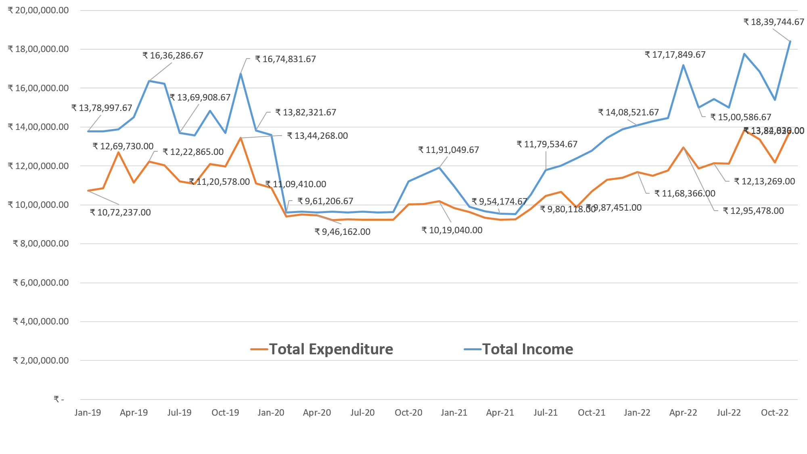

(b) Year Wise Profit From Different Ledgers. From year wise profit share of different ledgers, it emerges that ‘Guest Room’ ledger contributes maximum to the profit. However during Covid -19 periods , profit from this ledger suffered heavily and it ran in to loss during these periods due to maintenance charges incurred on these rooms, and very less income from these rooms. Following is the yearly share of different ledgers in total profit:-

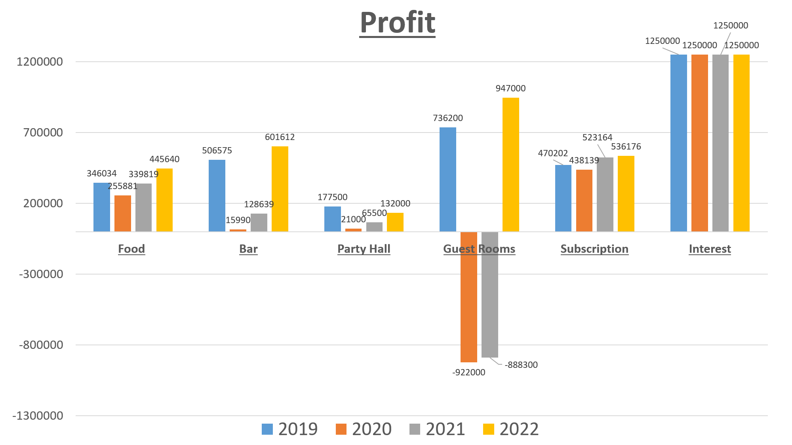

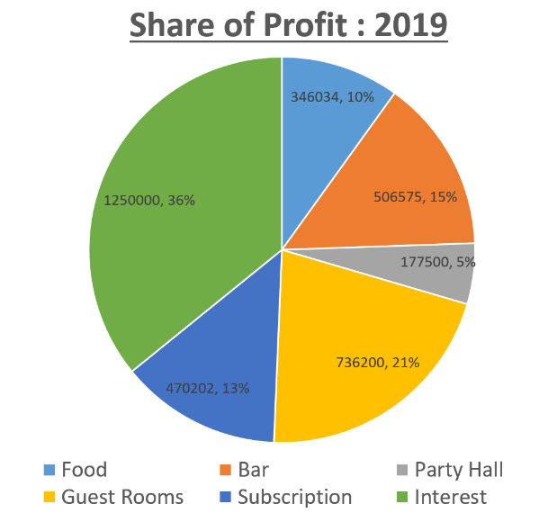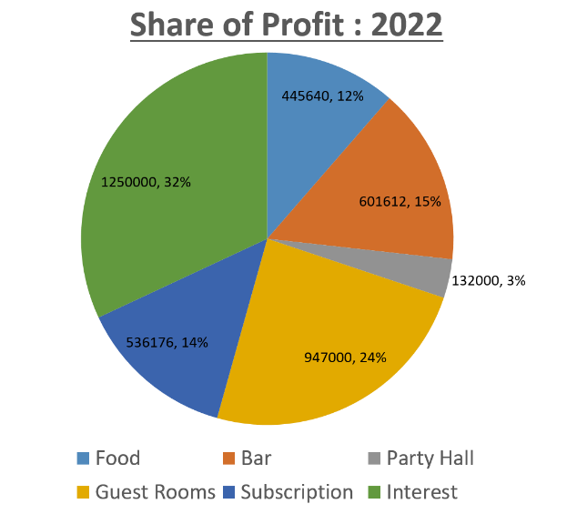

(c) Role of Mess Subscription. Mandatory monthly mess subscription of all the members has shown consistent income and expenditure. Same is reflected in the monthly average profit of this ledger. After enquiring from the Mess office, it was found out that this ledger is used for payment of electricity and water charges, insurance premium and payment of wages of office staff. This ledger along with ‘Interest from Bank’ effectively sustained the mess operations during the Covid -19 periods. Following is the ‘Mess Subscription’ line chart:

(d) Role of ‘Interest from Bank’. ‘Interest from Bank’ is paid on yearly basis on Fixed Deposit of Rupees 2 crores in bank. Monthly share of the yearly interest was taken into the account. Total profit of the mess was calculated deducting this amount and it emerged that mess ran in loss in absence of this amount during Covid-19 periods. Therefore, this ledger played a very important role in sustenance of mess operations during Covid -19 periods. Following is the visual representation of the aforesaid analysis:

(e) Partying Habit. If we compare the profit generated from booking of ‘Party Halls’, it emerges that it has decreased in 2022 in comparison to 2019. Therefore, it can be deduced that partying habit of individuals has declined.

(f) Mess Operations. Study of the income, expenditure and profit statements reveals that ‘Bar’, ‘Guest Rooms’ and ‘Party Halls’ suffered heavily during the Covid-19 period, however the expenditure on ‘Guest Rooms’ and ‘Bar’ continued. It was checked with the Mess office and it was found out that this expenditure was incurred on the wages of the people employed for maintenance of rooms and bar. It reveals that the Officers’ Mess did not resort to firing of staff during Covid -19 periods and it reflects a very positive culture of the Officers’ Mess.

(g) Major Recommendation. Considering the role of ‘Interest from Bank’ during Covid -19 periods towards sustenance of Mess operations, it is recommended that the Officers’ Mess amy increase the amount of “Fixed Deposit’ in the bank. This would support the mess during any lean periods like Covid -19 or any other contingency. Considering the similarity of the Officers’ Mess and resorts/hotels, same would be applicable for these businesses.